
PinJig Split Migration Rules –
Structural Manufacturing

PinJig Split Migration Rules.doc
Status: Draft
Author: StructMfg-Team

SM3D Concept Design Document.
December 20 , 2011
© 2011 Intergraph Corporation. All rights reserved.
The content of this document is proprietary work of Intergraph Corporation, or relevant third parties, and is protected by copyright law and international treaty. Any use, duplication, distribution or disclosure of such, other than as specified herein, is unauthorized and in violation of applicable copyright law and international treaty. All rights in content or materials bearing copyright notice or other attribution of third party rights are reserved to the relevant third party. United States Government license rights are limited to those mandatory rights identified in DFARS 252.227-7015(b).
Intergraph may make improvements and/or changes in the products and/or the programs described in this publication at any time without notice.
Any content or materials supplied hereunder are provided "as is," without warranty of any kind, either expressed or implied, including, but not limited to, any implied warranties of merchantability, fitness for a particular purpose, or against infringement. In no event shall Intergraph be liable for any damages arising out of, or in connection with the downloading, viewing, use, duplication, distribution or disclosure of any content or material published by Intergraph, including but not limited to any direct, indirect, incidental, special, punitive or consequential damages, or loss or corruption of data.
Some jurisdictions do not allow the exclusions or limitations set forth above, so the above may not apply to you. The exclusions or limitations shall apply in all jurisdictions to the maximum extent allowed by law.

Intergraph Corporation
170 Graphics Drive
Madison, AL 35758
Phone: +1.256.730.2000
Toll Free USA: +1.800.345.4856
Fax: +256.730.2048

Contents
Introduction 2
References 2
Definitions 2
Bulkload 3
Rule Framework and Implementation 3

Revision # | Date Revised | Revised By | Description
0.1 | 20- Dec- 2011 | Manasa Jaisetty | Initial Version.

Introduction
The purpose of this document is to describe the framework of PinJig split migration rule.

References

Definitions

Bulkload
- The split migration rule is avialble in “MfgMigrationRules” sheet(RuleType = 411). User can modify the prog-id for “CPinJig_Migration” rule.
Location: “\ShipCatalogData\BulkLoad\DataFiles\StructManufacturing\StructMfgSettings.xls”

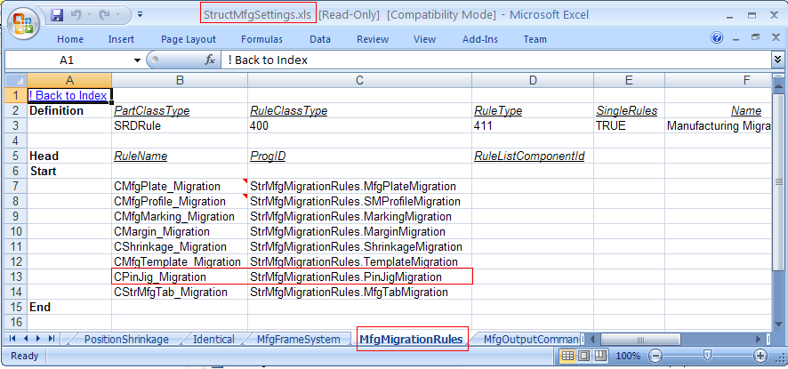

Rule Framework and Implementation

The PinJig split migration rule is delivered at the below location:
- “\SharedContent\Src\StructManufacturing\Rules\PinJig\ SplitMigration”

The purpose of this rule is to specify the behavior of Pinjig objects when their parent parts are split/merged. It determines the pin jig split migration in the model.

When the PinJig parent part is split, this rule decides the detailed part to which the PinJig needs to be migrated. If a reverse migration is done, this rule decides the PinJig that needs to be retained.

WORKFLOW:

- Whenever user performs a split operation (in Molded Forms task) on the PinJig parent system, the manufacturing split migration semantics invokes the rule
- Whenever the plate parts are merged(i.e) deletion of a splitter is done, the manufacturing split migration semantics invokes the rule.

The split migration rule class(PinJigMigration.cls) implements “IJMfgSplitMigration” interface.
Following methods are exposed on IJMfgSplitMigration interface:
1. MigrateObject
Signature: Private Function IJMfgSplitMigration_MigrateObject(ByVal pOldObj As Object, ByVal pReplacingObjColl As GSCADStructMfgGlobals.IJElements, ByVal pMfgObject As Object, pbCreateMfg As Boolean, Optional pOptionalArg As Boolean) As Object
Input: Old part, new part collection, input PinJig for which the split notification semantic is triggered
Output: Creation flag which indicates whether to create new Pinjigs, Clone flag which indicates whether to clone the object settings , the detailed part to which the Pinjig needs to be connected
Description: This method returns the creation flag, clone flag and a detailed part from the input collection to which the PinJig needs to be migrated.
- The current implementation returns “False” for creation flag indicating that PinJigs should not be created automatically for new plates.
- Clone flag is also set to “False”
- From the input collection of new parts, the detailed part with the largest surface area is returned as the output. This is the part to which the Pinjig would be migrated.
2. ReverseMigrate
Signature: Private Function IJMfgSplitMigration_ReverseMigrate(ByVal pReplacedPartColl As GSCADStructMfgGlobals.IJElements, ByVal pReplacingPart As Object, ByVal pMfgObjsColl As GSCADStructMfgGlobals.IJElements, pbCreateMfg As Boolean, Optional pOptionalArg As Boolean) As Object
Input: Collection of detailed parts which are getting replaced, new detailed part, Collection of affected manufacturing objects for the replaced parts
Output: Creation flag which indicates whether to create new Pinjigs, Clone flag which indicates whether to clone the object settings , the PinJig that needs to be retained
Description: This method returns the creation flag, clone flag and the Pinjig that needs to be retained.
- The current implementation returns “False” for creation flag indicating that new PinJigs need not be created
- Clone flag is also set to “False”
- From the input collection of manufacturing objects, the Pinjig supporting the detailed part with the largest surface area is returned as the output. This is the pinjig that needs to be retained.

